**ANGULAR POSITION CONTROL OF A DC MOTOR USING PID CONTROLLER**

**Lab Project: Power Transmission**

***Submitted To***

**Sir Alamdaar Hussain**

***Submitted By***

**Suhaib Safdar (FA19-BEE-013/ATK)**

**ACKNOWLEDGEMENT**

First of All, we thank to ALLAH Almighty, the Most Merciful, who gave us strength to complete this project. Then to our parents who support and encourage us. We would like to thank Sir Yasir Muhammad and Sir Hassan Saeed Qazi for their helpful guidance in this project. Throughout the semester, they provide their very valuable comments based on our output and put us back onto the right track. Without their inspiriting comments, this project would become very impractical for general use. Last but not the least, we would like to thanks to all my friends and seniors who share their experiences with us.

**Table of Contents**

ABSTRACT 4

CHAPTER I 5

Introduction 5

1.1 Introduction: 6

CHAPTER II 8

Circuit Components 8

2.1 Circuit Components 9

2.1.1 TRIAC 9

2.1.2 DIAC 10

2.1.3 Resistor 10

2.1.4 Capacitor 10

2.1.5 Induction Motor 11

CHAPTER III 14

Circuit Diagram, its Working and Applications 14

3.1 Block Diagram 15

3.2 Circuit Diagram 15

3.3 Working 16

3.4 Simulation Results 16

3.5 Applications 17

3.6 Hardware Results 18

18

**CHAPTER IV 19**

**Advantages, Conclusion & References 19**

4.1 Advantages 20

4.2 Conclusion 20

4.3 References 20

# 

# ABSTRACT

Nowadays,the DC motors are used in various applications such as defense, industries, robotics because of their simplicity, ease of application, reliability and cost effective. Generally in a DC Motor, speed control can be achieved by varying the terminal voltage but position control of the shaft cannot be achieved. The position control of a DC motor is crucial in applications for precision control system. The purpose of a motor position controller is to take a signal representing the required angle and to drive a motor at that position. Arduinos can provide easy control of a DC motor.

Typically, Arduinos are used to implement PID controllers. They receive the input pulses from the encoder, then feed them through a control algorithm to output the motor speed. Software based PID gives us more reliable control upon any parameter you want affecting your response, but hardware is typically harder to adjust.

The proposed design describes the designing and development of a Angular Position Control of DC Gear Motor using PID Controller. It is based on HC05 bluetooth module and L298 Motor driver which is dedicated for motor control applications. The designed drive is a low-cost motor control drive used to control the angular position of DC gear motor and is targeted for industrial and electric appliances e.g. power winches on trucks, windshield wiper motors and power seat or power window motors. Jacks, cranes, lifts, clamping, robotics, conveyance, and mixing are just some of the applications gearmotors are used for in industry.

# CHAPTER I

# Introduction

## 1.1 Introduction:

# In this project, a PID controller design for a DC motor angular position control. DC motor angular position systems are usually controlled by proportional integral- derivative (PID) control algorithms with PID coefficients tuned for optimizing operation. The objective of a PID controller in a position control system is to maintain a position set point at a given value and be able to accept new set-point values dynamically. Modern position control environments require controllers that are able to cope with parameter variations and system uncertainties. To implement a PID controller the proportional gain KP, the integral gain KI and the derivative gain KD must be determined carefully. controlling the DC motor without using the PID controller will give some oscillation in the signal and because the system is nonlinear, controlling by function is the best way to control the nonlinear systems and PID controller is the best choice to achieve this task.

# CHAPTER II

# Circuit Components

## 2.1 Circuit Components

Following components are required to make the

|  |  |  |  |
| --- | --- | --- | --- |
| **SL.NO.** | **NAME OF THE COMPONENT** | **SPECIFICATIONS** | **QUANTITY** |
| **1.** | ARDUINO | NANO | 1 |
| **2.** | DC GEAR MOTOR WITH ENCODER | TG-47C-SG-100-E221 | 1 |
| **3.** | BLUETOOTH MODULE | HC - 05 | 1 |
| **4.** | MOTOR DRIVER IC | L289 | 1 |

### **Arduino Nano**

The Arduino Nano is Arduino's classic breadboard friendly designed board with the smallest dimensions. The Arduino Nano comes with pin headers that allow for an easy attachment onto a breadboard and features a Mini-B USB connector. The classic Nano is the oldest member of the Arduino Nano family boards.

**Specifications:**

1. Operating voltage: 5 [volts](https://en.wikipedia.org/wiki/Volts)
2. Input voltage: 6 to 20 volts
3. Digital I/O pins: 14 (6 optional [PWM](https://en.wikipedia.org/wiki/Pulse-width_modulation) outputs)
4. Analog input pins: 8
5. [DC](https://en.wikipedia.org/wiki/Direct_current) per I/O pin: 40 mA
6. DC for 3.3 V pin: 50 mA
7. [Flash memory](https://en.wikipedia.org/wiki/Flash_memory): 32 KB, of which 0.5 KB is used by [bootloader](https://en.wikipedia.org/wiki/Booting#Boot-loader)
8. [SRAM](https://en.wikipedia.org/wiki/Static_random-access_memory): 2 KB
9. [EEPROM](https://en.wikipedia.org/wiki/EEPROM): 1 KB
10. Clock speed: 16 [MHz](https://en.wikipedia.org/wiki/MHz)
11. Length: 45 mm
12. Width: 18 mm
13. Mass: 7 g
14. USB: Mini-USB Type-B [[5]](https://en.wikipedia.org/wiki/Arduino_Nano#cite_note-5)
15. ICSP Header: Yes
16. DC Power Jack: No

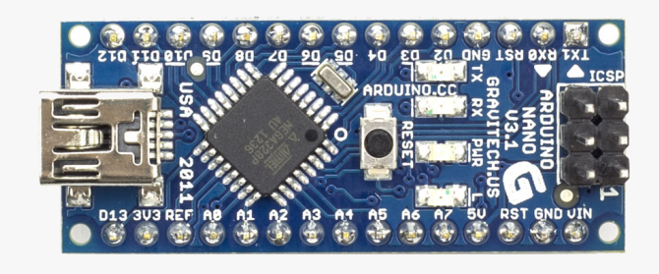

Figure 1: ARDUINO NANO

### **L298 Motor Driver IC**

An **L298 Motor Driver IC** is a monolithic chip, used in motor driver modules to control the speed of a [DC motor](https://www.elprocus.com/dc-motor-basics-types-application/). At present, the most frequently used motor driver ICs as compared to L298 is; L293D & L2938N. This IC is frequently used in RC cars & autonomous robots. The input provided to a motor driver module is taken from a controller like [Arduino](https://www.elprocus.com/arduino-basics-and-design/).

So this logic input is simply used to control the direction of the motor which is connected to the motor driver IC. The motor driver module mainly includes a motor driver IC, which is an essential component in this module. This single IC can control the motor alone but using the motor driver module by interfacing it with Arduino can make it easy.

It is a low voltage operating device like other ICs. L293D provides the continuous bidirectional Direct Current to the Motor. The Polarity of current can change at any time without affecting the whole IC or any other device in the circuit. L293D has an internal H-bridge installed for two motors.

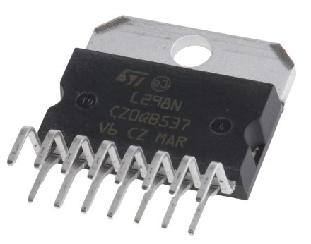

Figure 2: L298 MOTOR DRIVER IC

**Pin Configuration**

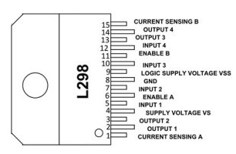

|  |  |
| --- | --- |
| Pins | Detail |
| **Pin1 (Current Sensing A)** | This pin is used to control the flow of the current of the load. |
| **Pin 2 & 3(Output 1 & 2)** | These two pins are output pins of the H- Bridge A where the current supplies throughout the load which is monitored at pin-1 |
| **Pin4 (VS)** | This is a voltage supply pin, connected to +5V. |
| **Pin5 & 7 (Inputs)** | Control Inputs of the Bridge A & compatible with TTL |
| **Pin6 (Enable A)** | This is an enable input with TTL compatible |
| **Pin8 (GND)** | This is a GND pin |
| **Pin9 (Logic Voltage Supply)** | This pin provides voltage supply for the logic blocks. |
| **Pin10 & 12 (Inputs3 & 4)** | These are control inputs of bridge-B and compatible with TTL |
| **Pin11 (Enable B)** | This is an enable Input with TTL compatible |
| **Pins 13 & 14 (Output 3 & 4)** | These are output pins of the H- Bridge B where the flow of current throughout the load is monitored at pin15. |

**Features and Specification**

The**features and specifications of L298 IC** include the following.

1. The operating voltage supply is up to 46 v.
2. Total DC is up to 4A.
3. The saturation voltage is less.
4. Protection from over temperature.
5. Power dissipation is 25w.
6. Operating voltage ranges from +5 to +46v
7. The maximum voltage supply voltage is 50v.
8. Maximum input & enable voltage is +7v.
9. TTL controlled inputs.
10. Storage temperature ranges from -40°c – 150°c.
11. Operating temperature ranges from -23°C to – 130°C
12. The maximum allowed the current flow to draw through every output is 3a.

**Applications of L298 Motor Driver IC**

1. L298N motor driver IC is used in different fields like robotics, embedded, etc. We know that microcontrollers work with very little voltage and current but motors use high voltage and current. So, for this reason, motor driver ICs are used to provide high voltage and current.
2. L298 motor driver is applicable where H- BRIDGE is used.
3. This motor driver is used in high power-based applications.
4. This IC is used where current control & PWM operable IC is required.
5. This IC is used where the control unit provides only TTL outputs.

### **2.1.3 Bluetooth HC 05 Module**

The **HC-05** is a popular bluetooth module which can add two-way (full-duplex) wireless functionality to your projects.

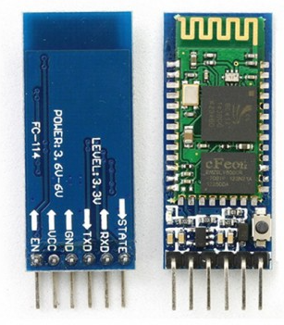

Figure 3: HC - 05 Bluetooth Module

**Pin Configuration**

The following is the pin configuration of Bluetooth Module HC - 05.

|  |  |  |
| --- | --- | --- |
|  |  |  |
| 1 | Enable / Key | This pin is used to toggle between Data Mode (set low) and AT command mode (set high). By default it is in Data mode |
| 2 | Vcc | Powers the module. Connect to +5V Supply voltage |
| 3 | Ground | Ground pin of module, connect to system ground. |
| 4 | TX – Transmitter | Transmits Serial Data. Everything received via Bluetooth will be given out by this pin as serial data. |
| 5 | RX – Receiver | Receive Serial Data. Every serial data given to this pin will be broadcasted via Bluetooth |
| 6 | State | The state pin is connected to on board LED, it can be used as a feedback to check if Bluetooth is working properly. |
| 7 | LED | Indicates the status of Module   * Blink once in 2 sec: Module has entered Command Mode * Repeated Blinking: Waiting for connection in Data Mode * Blink twice in 1 sec: Connection successful in Data Mode |
| 8 | Button | Used to control the Key/Enable pin to toggle between Data and command Mode |

### **DC Gear Motor with Encoder**

The 12V Namiki DC gear-motor shown in Fig. 4 is a powerful motor to drive the position control system. It comes with the photoelectric encoder output and planetary gear ratio reduced by 80:1 gear. It can provide 120 rpm with the rated voltage of 12VDC [5]. To read the count values from the encoder, the user would check the condition of channel A and B rotation applying by experiment. For the rotor shaft count per revolution values, it is very important to multiply the gear ratio by count values. The specification of the motor

**Specification:**

* No load speed: 126rpm
* Workable Voltage:6-24V
* Rated voltage: 12V
* No load current：46mA
* Load torque: 0.85kg.cm
* Load current: 250mA
* Load output:1.25W
* Stall torque: 4.2kg.cm
* Reducer ratio:1:34
* Reducer size: 21mm
* Weight: 85g
* Operating Temperature Range: -40℃~120℃

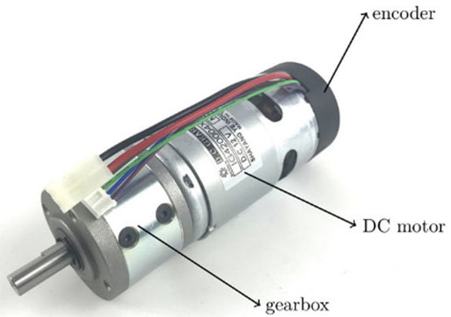

Figure 4: DC Motor

# CHAPTER III

# Circuit Diagram, its Working and Applications

## 3.1 Block Diagram

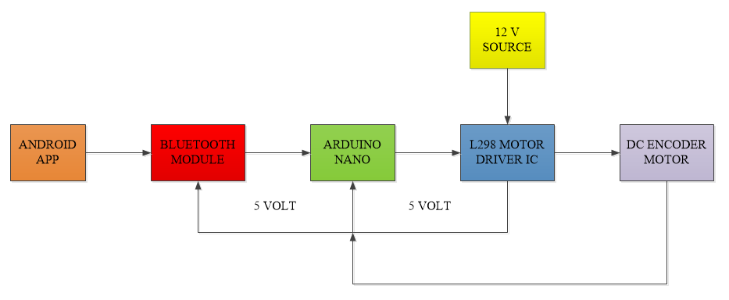

## 3.2 Circuit Diagram

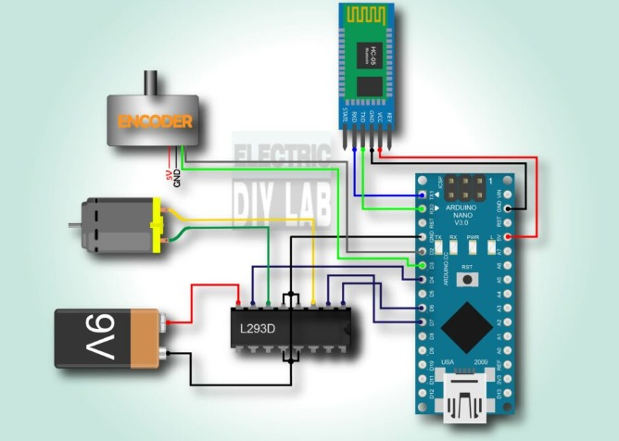

## 3.3 Working

The circuit controls the speed of the 12-V DC motor using the Android app on a smartphone. The app sends the commands to start or stop the motor and to change the Angular position(0-360 and 360-0) of the motor via the smartphone’s Bluetooth.

These commands are received by the HC05 module, which passes them on to the Arduino NANO via the Tx and Rx pins. As per the commands sent over, Arduino will run or stop the DC motor and vary its Angular position/rotation from 0 to 360 and vice versa. Arduino generates a PWM signal on its pin to run or stop the motor or to vary the motor Angular position. To stop the motor, the pulse width on the pin D2 and D3 is 0 (0%). And to rotate the motor at 360 degree, pulse width on the pin D2 and D3 is (100%). So, as Arduino changes the pulse width on its pin, the motor Angular position changes from min to max or vice versa.

## 3.4 Simulation Results

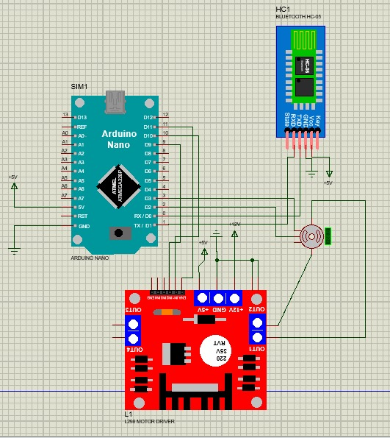

## 3.5 Applications

DC motors are used in various applications such as:

1. Defense.
2. Industries.
3. Robotics because of their simplicity, ease of application, reliability and cost effective.
4. It is also used for robotic manipulators, guided vehicles, steel rolling mills, cutting tool, overhead cranes, electrical traction and other application etc.

## 3.6 Hardware Results

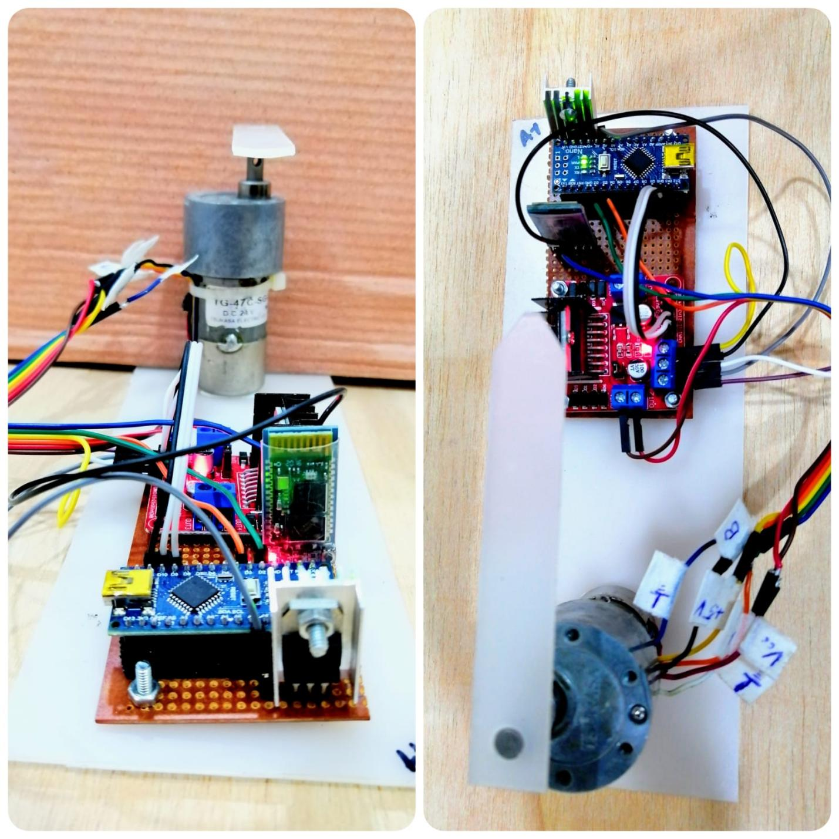

## CHAPTER IV

## Advantages, Conclusion & References

## 4.2 Advantages

The proposed system has the following advantages:

## By integrating the PID controller to the DC motor were able to correct the error made by the DC motor and control the angular position of the motor to the desired point.

## The proposed system has an advantage in both noise reduction and oscillation reduction and the control system runs well, and has a good system response.

## 4.2 Conclusion

## A PID based Angular Position Control of DC Geard Motor has been designed and implemented successfully. In whichinput signal is send from Android app directly to HC-05 bluetooth module to the Arduino board via Rx and Tx pins for DC motor control system using L298 Motor driver. PID Gain tuning method is a good choice to reduce the oscillation according to the observed system response. Moreover, PID with friction compensation for control system operates well, especially it has no overshoot, small rise time, no oscillation and steady state error is nearly equal to zero to accomplish the designed criteria of the control system. Therefore, the experimental results are very optimal to get the desired angular position of DC motor.

## 4.3 References

1. K. Sailan and K.D. Kuhnert, “DC Motor Angular Position Control using PID Controller for the purpose of controlling the Hydraulic Pump”, International Conference on Control, Engineering and Information, Vol. 1, No. 2, pp. 22,26, 2013.
2. H. Paul and S. Lasrado, “Precise Control of Angular Position of Geared DC Motors for Low Cost Applications”, International Journal of Innovative Research in Science,Engineering and Technology, Vol. 5, Special Issue 9, May 2016.
3. D. Xue, C. Zhao, Y.Q. Chen, Fractional Order PID Control of a DC Motor with Elastic Shaft: A Case Study, Proceedings of the 2006 American Control Conference, USA, 2006.
4. K.J. Astr ˚ om, and T. H ¨ agglund, ¨ Advanced PID control, ISA-The Instrumentation, Systems, and Automation Society, 2006.